No Boundaries Transportation Maintenance Innovations
Technical Advisory Committee

Technical Advisory Committee Call
April 12, 2021

Meeting Minutes—DRAFT

Attendees

Colorado DOT: Tyler Weldon, David Reeves
Idaho TD: Seth Helms
Illinois DOT: Stephanie Dobbs
Indiana DOT: Tony McClellan
Maine DOT: Jim Saban
Maryland DOT: Sandi Sauter
Michigan DOT: Todd Rowley
Minnesota DOT: Clark Moe
Mississippi DOT: Heath Patterson
Missouri DOT: Mike Shea
New York State DOT: Ken Relation, John Izzo
North Dakota DOT: Jesse Kadrmas
Ohio DOT: Doug Gruver
South Carolina DOT: Cruz Wheeler
Texas DOT: Alanna Bettis, Shelly Pridgen
Wisconsin DOT: Chris Ohm
CTC & Associates: Brian Hirt, Kirsten Seeber, Vaneza Callejas, Katie Johnson, Chris Kline
DW Clonch: Diana Clonch, Diane Watkins

Attachments
- CTC & Associates/DW Clonch — Takeaways and Opportunities from the 2021 TRB Annual Meeting
- CTC & Associates — Budget Overview
- CTC & Associates — No Boundaries Year 1 Tasks for Discussion
Welcome and Opening Business
- Call to Order — TAC Chair Tyler Weldon, Colorado DOT
- Introduce new TAC members — Brian Hirt, CTC & Associates
  - Tony McClellan (IN) – Seymour District Deputy Commissioner
  - Jesse Kadrmas (ND) – Assistant District Engineer for Grand Forks District
- Pointer to website and peer exchange materials — Brian Hirt
  - All materials from the February/March 2021 Peer Exchange are on the website. Members can log in to access all materials.
- Opportunities from TRB meeting (attachment) — Brian Hirt
  - This document outlines noteworthy presentations and recent research, upcoming research and planning, and liaison opportunities for No Boundaries.
Commitments, Transfers, Budget, and Spending — Kirsten Seeber, CTC; David Reeves CDOT
- Current total commitments to No Boundaries = $670,000
- Current funds received by CDOT as of 4/12/21 = $350,000
- Left to be paid = $320,000
- Total projected funds as of 4/12/21 = $990,000 (More commitments will be made. Some states are only allowed to commit one year at a time.)
- Task Order 1 budget = $174,392. Task Order 1 ends on 10/21/21.
- Total funds spent as of 3/31/21 = $56,780
- Bottom line is that No Boundaries is currently well funded and prepared for future pooled fund activities.
- All commitment and transfer questions can be directed to Kirsten Seeber at kirsten.seeber@ctcandassociates.com
Database Scoping and Recommendation — Database Committee; Chris Kline and Vaneza Callejas, CTC
- Progress report on scoping effort
  - The subcommittee members are Clark Moe, David Reeves, Mike Shea, Tyler Weldon and Diana Clonch. Other members are welcome to join. Send Tyler an email if interested.
  - CTC sent an Interim Progress Report to the subcommittee on 4/5/21.
  - Project tasks
    - Task 1: Investigate models and best practices among states and national organizations.
      - This task is in progress. CTC is still gathering information on current agency practices.
      - There is an NCHRP Project (20-123(09) Innovation Platform Survey) that is looking at a similar topic. This projects has sent a survey to all state transportation agencies. Sid Mohan, NCHRP, has indicated they will be sharing survey results in the next several months but CTC can get early results and learn about the project’s next steps in May.
        - Brian recommends taking a wait and see approach on the applicability of NCHRP project to our project.
    - Task 2: Consider possible leveraging of a low-cost rebuild of the innovation database using existing web tools managed by CTC.
  - Notes and comments
    - Tyler – This project is in the learning phase right now and will rely on CTC to recommend the direction the TAC should go.
    - Chris K. – CTC will address all subcommittee questions in the final task memo.
    - Brian – The database serves the purpose of gathering information and as a tech transfer tool to display the innovations.
  - Action item: CTC will deliver a final task memo by April 30, first to the subcommittee and then, pending comments/revisions, with the full TAC.

Task Order 1 Review — Brian Hirt
- Brian reviewed Task Order 1 with the members to remind them of the activities included in it.
- Synthesis efforts (an effort listed in the Task Order #1)
  - Workforce development
    - The TAC has been discussing this as a possible synthesis effort for years. The Clear Roads pooled fund is currently working on a synthesis related to recruitment and retention, which Diana is working on.
    - Diana – Potential topics for a No Boundaries workforce development synthesis
      - Problem statement identification – What does workforce development mean?
      - Pandemic Related Considerations – Lessons learned
      - Retention
      - Recruitment
      - Current Research and Available Data and Resources
  - COVID-related needs based on roundtable
  - Other topics
    - Clark suggested two additional synthesis topics.
      - Syntheses of State DOT/LTAP educational programs, including Road Scholars-like programs at LTAPs, and CDOT’s model program, and a possible program at Virginia Tech.
      - Synthesis of State DOT research-and-innovations program measures and if/how such measures are be tied to departmental measures.
  - A synthesis does not have to begin prior to the Task Order 1 end date (10/27/21), which can be extended by CDOT.
  - Brian would like to identify synthesis topics the TAC would like to work on.
- Other significant efforts to address in year 1
  - If there is anything that the TAC wants CTC to work on within the Task Order let us know.
Virtual meetings — Discussion
- Recap and feedback on Feb/March Meeting
  - All members who spoke thought the virtual Peer Exchange went well, with enough time to adequately address the topics but not too long that attendees lost interest.
  - The consensus is that members want to meet again in person as they get much more out of these meetings, especially from side conversations and from the tours.
- Desire for 1- or 2-part virtual session this summer
- Hybrid business meeting/tech transfer
- Topics/hot issues
In-person Meetings — Discussion
- Fall 2021/Spring 2022 Peer Exchange
  - Who can host?
    - CDOT a possibility. If another state can host, please speak up.
  - Who can travel? (Definitely, maybe, or definitely not)
    - Mentimeter poll
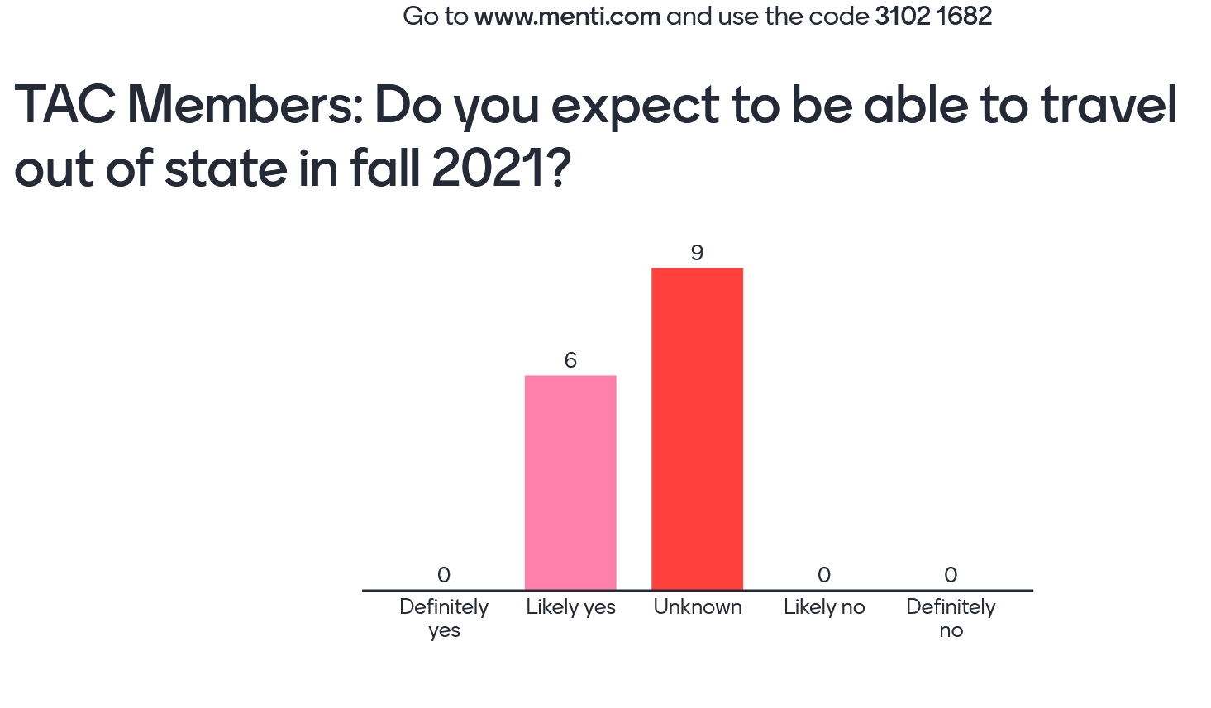
    - Mentimeter poll
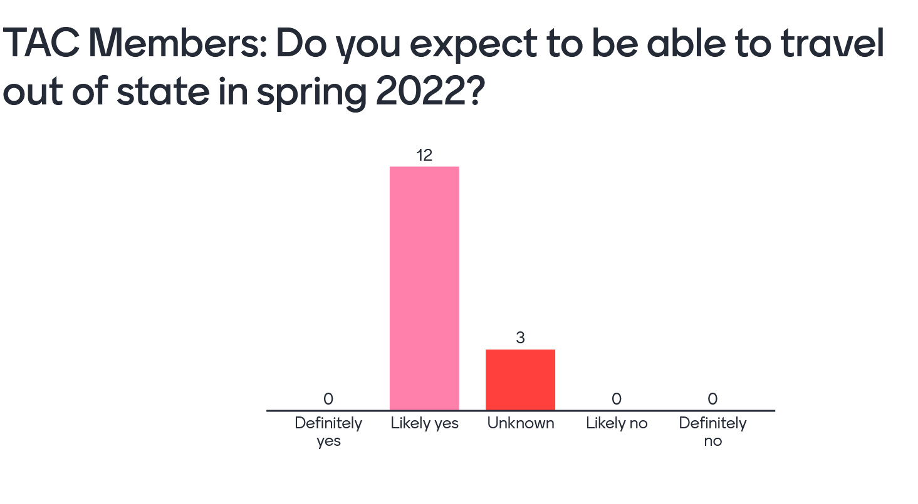
  - Virtual/in-person hybrid options
    - The TAC should plan on holding a hybrid in person/virtual meeting in fall 2021.
  - Framing the business case for the added value of in-person meetings
    - Tyler feels the TAC should be unified in saying that in-person meetings are better than virtual meetings and the reasons. This will help all members make a business case to their management for attending and/or hosting.
      - CTC will put together a travel memo that will make the case, in the strongest terms possible. We can get feedback from TAC on the language.
    - Stephanie suggested that agencies that also belong to Clear Roads to pay attention to what they are doing with their fall 2021 meeting. If they are meeting in person, this could pave the way for No Boundaries members to attend an in person meeting. Clear Roads meets this week so we will know more soon.
  - Adding travel to Task Order #2
    - CDOT will create a Task Order for travel-related expenses.
Strategic Direction for No Boundaries — Discussion
- Is No Boundaries serving member needs?
  - No Boundaries and Clear Roads are frequently compared since both pooled funds address different sides of maintenance. Clear Roads conducts research projects and No Boundaries’ focus is on innovations and idea sharing. Tyler wants to confirm that the members want to maintain this focus as their long-term sustainable goal. Is No Boundaries serving the needs of the TAC members?
    - The members agreed that No Boundaries should not start conducting research. One suggestion is for No Boundaries to host technical peer exchanges with the right people from the right states.
  - The involvement of Tony Nieves and James Bryant is positive for the study. TRB is focusing on innovation. No Boundaries could be the clearinghouse for DOT innovation, which is the original goal for the pooled fund. This might be the right time considering that TRB and FHWA are focused on innovations implementation.
    - We don’t want No Boundaries to become a “parking lot” for other organizations or agencies for anything they come up with. Suggest looking at the AASHTO MAC categories as guidelines. This is being addressed in the database scoping project.
  - No Boundaries in person meetings can continue to showcase field innovations from the member agencies. In addition, invite someone from a national group (TRB, NCHRP) who has done a longer term research project on an innovation or procedure to showcase that type of information. Bigger things that members could contemplate that for their own agency.
    - Others are doing research so we don’t need to go that route.
    - Rapid deployment of innovations. No Boundaries could be the megaphone to communicate innovations to others.
    - Look at the LTAP Build a Better Mousetrap program as a potential model for No Boundaries.
- What should No Boundaries be doing more or less of? Build into Task Order #2.
- Other topics
Action items:
- Database subcommittee to review the memo and discuss with full group at the next TAC meeting in June.
- Workforce development synthesis – Decide on this at the June TAC meeting.
- TAC members should send other synthesis ideas to be discussed at the June meeting.
- TAC members should check to see if they could host an in person meeting.
Adjourn — Tyler Weldon

