
No Boundaries Roadway Maintenance Practices

Technical Advisory Committee Meeting

Technical Advisory Committee Call
December 16, 2020

Meeting Minutes—DRAFT

Attendees
Colorado DOT: Tyler Weldon, David Reeves  Idaho TD: Seth Helms  Maine DOT: Jim Saban  Maryland DOT: Sandi Sauter  Michigan DOT: Todd Rowley  Minnesota DOT: Clark Moe  Mississippi DOT: Heath Patterson  Missouri DOT: Mike Shea  New York State DOT: Ken Relation | Ohio DOT: Doug Gruver  South Carolina DOT: Cruz Wheeler  Texas DOT: Alanna Bettis, Shelley Pridgen  Virginia DOT: Bill Collier  Wisconsin DOT: Chris Ohm  CTC & Associates: Brian Hirt, Kirsten Seeber, Chris Kline, Katie Johnson  DW Clonch: Diana Clonch, Diane Watkins
Call to Order and Welcome — TAC Chair Tyler Weldon, Colorado DOT

Updates from last call — Brian Hirt
- Web link: menti.com
  - To encourage feedback from all members, TAC members were prompted to answer an onscreen question using Mentimeter.com, a free, real-time polling software. The group used this twice more during the meeting.
- The TAC reviewed the action items from the November meeting minutes.
  - Website
    - CTC updated the No Boundaries logo, operating procedures and contact information.
    - Weekly news item emails have started. TAC members should let Brian know if they are not receiving them. Members should send Brian news items they would like featured in a weekly email.
    - TAC members and consultants should send a casual, personal photo of themselves to Brian for posting on the No Boundaries website.
- FHWA liaison
  - The FHWA liaison assigned to No Boundaries is Tony Nieves Torres, Construction Engineer, FHWA Office of Infrastructure, Construction Management Team. Brian has communicated with Tony and will meet with him to catch him up on the pooled fund activities.

- Database Working Group
  - Brian is working on getting this group started.

Budget Update and Membership — Kirsten Seeber; David Reeves
- New York State has completed its FY21 transfer and Missouri has started its FFY 21 transfer. Kirsten will send an email to members and research contacts about FFY21 commitments and transfers.

New Business
Solicit Nonmember States
- Targeting other states and non-state entities
  - What do members feel the No Boundaries selling point is in a year where everything is virtual?
    - Shelley Pridgen stated that innovation might be the key. Since many agencies have had to innovate to operate in a COVID-19 environment, that might be incentive to join the pooled fund and share ideas. However, some agencies may not be able to join due budget constraints and might not see this as a priority.
      - Ken Relation agreed with Shelley.
      - Clark Moe suggested using the innovation angle as way to reach out to the research directors.
    - Diana Clonch was asked if this was the right time to reach out to her partners. Diana recommended holding off because those agencies are also experiencing budget difficulties. APWA isn’t able to host its conferences, which is a big revenue generator, so we should wait for that group to get back on track.
    - Seth Helms asked about contacting British Columbia. Brian reminded the group about our previous experience with Manitoba. We learned that maintenance is privatized in the Canadian provinces so technical transfer and information sharing is not as prevalent as it is between DOTs. If someone has a contact, that might be the best way to reach out and invite them be a guest at a TAC meeting.
    - ACTION: CTC will reach out to the Research Directors and State Maintenance Engineers about No Boundaries. Tyler will assist.
      - The email will emphasize the use of federal dollars instead of an agency’s own budget.
      - Brian suggested inviting a few potential new members be guests at our peer exchange so they can experience No Boundaries.

Marketing Brochure
- Brian showed the current brochure at maintainroads.org/download/no-boundaries-two-page-brochure
  - The question of updating the brochure—used primarily in the past as a handout for in-person meeting—was deferred for future discussion.
Next Peer Exchange Event
- Dates—February, March 2021
  - ACTION: Brian to send an availability poll to all members for February and March. Poll in progress.
- Format
  - The peer exchange will be two 90-minute sessions (a Tuesday and a Thursday) over a few weeks.
- Content scoping with Mentimeter real-time polling during the call:
- What types of sessions would you like to include during a peer exchange/tech transfer virtual meeting (select your top 3)?
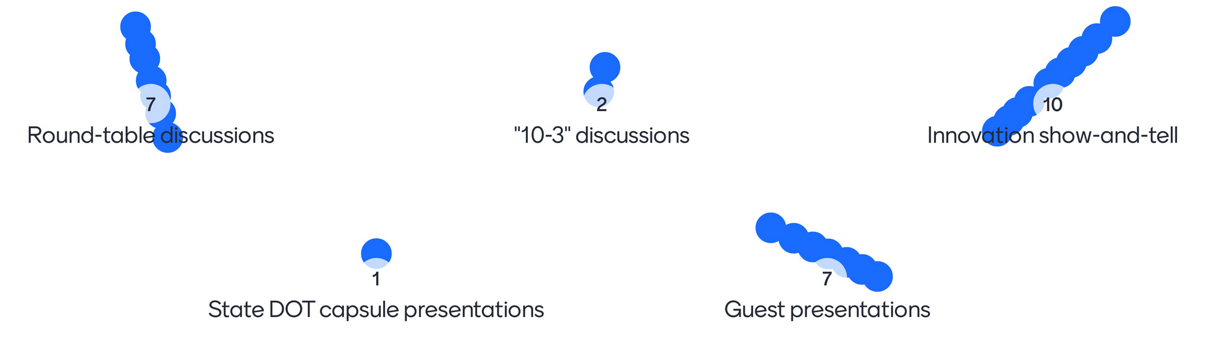
    - Round-table discussions – 25%
    - Innovation show-and-tell – 38%
    - “10-3” discussions (Take 10 minutes to discuss your 3 biggest issues and see what others are doing to address them) – 8%
    - State DOT capsule presentations (including members who haven’t presented in years or have had changes in their maintenance offices) – 4%
    - Guest presentations – 25%
- In a word or phrase, what topic would you like to address in a round-table discussion?
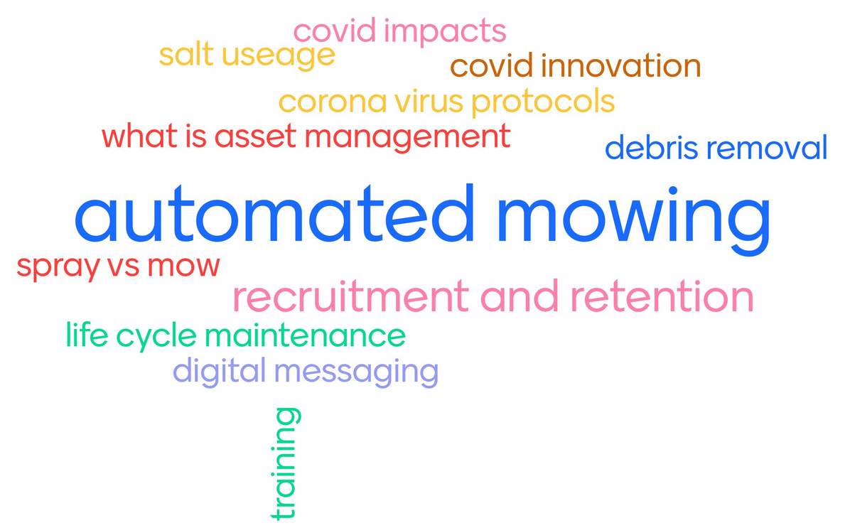
    - COVID-19, automated mowing, and recruitment and retention were the top topics.
- Meeting topics and text steps
  - Presentations
    - ACTION: Brian to invite Susan Baillargeon, Front Range Community College, to provide an update on the Highway Maintenance Degree program. Tyler will reach out to CDOT staff who have graduated from the program to provide their perspective.

  - Roundtable discussions
    - Innovations to address the COVID-19 situation. Tyler wants the group to focus on discussing the innovations that members have initiated to address these issues. ACTION: Brian will sketch this out and run it by Tyler and Doug Gruver.
    - Chris Ohm would like to include automated mowing as a topic as either a round table discussion or a quickfire question.
      - ACTION: Brian to reach out to Chris on this.
      - Minnesota’s mowing and spraying synthesis – Clark Moe reached out to TAC members on these topics and a consultant is synthesizing the information. He would like to include this in the discussion.
  - Each session may include an innovation show-and-tell at the end.
- Participation
  - The peer exchange is an opportunity for members to invite their colleagues who are experts on the featured topics. They can actively participate to share with the group or listen-only for information that would help them in their jobs.

Presentations at National and Regional Events
- January 2021 TRB committee meetings
  - No Boundaries members who attend maintenance-related TRB committee meetings were asked to let other attendees know—if feasible—that No Boundaries is back up and running.
  - Shelley suggested asking committee chairs if we could share a message and website link in a meeting’s chat window. We don’t know what platform TRB is using or if this option would be available, but it’s a good idea.
  - The online meetings and expanded calendar will make committee meeting attendance easier than in past years.
  - When TAC members are attending a committee meeting, please take any opportunities to mention the pooled fund or put the website link in a chat window.
- Develop calendar—future item for discussion.

Current and New Liaisons
- TRB, AASHTO, APWA, others
  - TRB – James Bryant
  - AASHTO MaC – Heath Patterson
  - APWA – Diana Clonch
  - AASHTO
    - Equipment Technical Working Group under AASHTO MaC – Tony Nieves
    - If a related group is doing things that intersect with No Boundaries, then we can get in touch with the group and ask to attend a meeting.
    - Tyler asked CTC to put together a list of AASHTO committees and send to the TAC so they can volunteer to attend meetings. ACTION: CTC to compile a draft list.
      - Brian asked if these groups are still meeting regularly online and are they open to other groups attending? Heath’s groups just had their national meeting but it was more business focused. When TAC members presented at the Roadway/Roadside committee meeting a couple of years ago and it went over well.

Adjourn
- TAC Chair Tyler Weldon adjourned the meeting.

