
No Boundaries Transportation Maintenance Innovations
Technical Advisory Committee

Technical Advisory Committee Call
Monday, June 7, 2021

Meeting Minutes—DRAFT

Attendees

California DOT: Theresa Drum
Colorado DOT: Tyler Weldon, David Reeves
Connecticut DOT: William Gombotz
FHWA: Antonio Nieves
Maryland DOT: Sandi Sauter
Michigan DOT: Todd Rowley
Minnesota DOT: Clark Moe
Mississippi DOT: Heath Patterson
Missouri DOT: Jimmy Shannon
New York State DOT: Ken Relation
North Dakota DOT: Jesse Kadrmas
Ohio DOT: Doug Gruver
South Carolina DOT: Cruz Wheeler
Texas DOT: Shelly Pridgen
CTC & Associates: Brian Hirt, Kirsten Seeber, Vaneza Callejas, Katie Johnson, Chris Kline
DW Clonch: Diana Clonch, Diane Watkins

Welcome and Opening Business
- Call to Order — TAC Chair Tyler Weldon, Colorado DOT
- Introduce new TAC members — Brian Hirt, CTC & Associates
  - Theresa Drum (CA) — Maintenance Safety, Equipment and Training Deputy Division Chief. Caltrans has rejoined the pooled fund.
  - Jimmy Shannon (MO) — Assistant District Maintenance Engineer. Mike Shea has retired and Jimmy is his replacement.
Commitments, Transfers, Budget, and Spending — Kirsten Seeber, CTC; David Reeves CDOT
- Current total commitments to No Boundaries = $700,000
- Current funds received by CDOT as of 6/7/21 = $370,000
- Left to be paid = $330,000
- Total projected funds as of 6/7/21 = $1,030,000 (More commitments will be made. Some states are only allowed to commit one year at a time.)
- Task Order 1 budget = $174,392. Task Order 1 ends on 10/27/21.
- Total funds spent as of 5/31/21 = $83,212
- The spending rate for year one (Task Order 1) is on pace.
  - CDOT plans to set up Task Order #2 to cover the September 2021 meeting costs.
  - David Reeves confirmed that any unspent funds in a Task Order go back to the pooled fund.
- All commitment and transfer questions can be directed to Kirsten Seeber at kirsten.seeber@ctcandassociates.com.
Database Scoping and Recommendation — Tyler Weldon, Colorado DOT
- Report on scoping effort
  - The Innovation Database Scoping and Recommendation final task memo was a great summary of recommendations. The goal is to maintain the database and keep it searchable. It should be robust, easier to use and better populated.
  - Partnering vs. re-build
    - Project NCHRP 20-139(09) is investigating a platform to capture State DOT innovations, but the final database could be a couple of years out.
- Costs
  - Development and implementation for all 3 options:
    - Option #1: Redesign the current database.
      - Cost: $26,100
    - Option #2: Rebuild the database using Clear Roads database architecture
      - Cost: $26,500
    - Option #3: Rebuild the database using Awesome Tables app
      - Cost: $30,910
      - CDOT Idea Cards are built on Awesome Tables app.
  - Operating costs for Option 2 versus 3
    - The operating cost per innovation is key. No Boundaries needs an effective and efficient way to post innovations. Example costs for 200 innovations are shown:
      - Option 3: $300/innovation x 200 innovations = $60,000
      - Option 2: $100/innovation x 200 innovations = $20,000
    - Tyler thinks that using the Idea Cards is an efficient way to populate the database. TAC members can enter innovations instead of consultants. The bigger effort may be collecting the innovations from the transportation agencies.
- Discussion
  - If a TAC member inputs an innovation, the costs are low as CTC would proofread entries only. It will cost more when CTC enters innovations. Relying on members to populate the database won’t make a robust database because proactive steps are needed to make it happen, regardless of the option chosen.
  - The TAC will eventually need to decide what is considered an innovation, worthy of being entered into the database.
  - It would be easier for CTC initiate either Option #2 or Option #3 versus having both options running simultaneously. Two options will also cost more. Going forward with two databases, until a final decision is made by the TAC, is workable. No Boundaries would not want to go public with two databases as this would be confusing to users.
  - Option #2 is more professional looking. Option #3 is visual and a quick read. Both options can be made to look similar. Option #3 (Idea Cards) needs to be formatted and can be customized to each innovation, depending on what is needed to best showcase the innovation. This is why CTC estimated a higher cost per innovation for this option.
  - Information can be pulled out of agencies’ individual innovation databases to populate the No Boundaries database.
  - Jimmy suggested that No Boundaries conduct a nationwide innovations challenge to collect innovations from across the country.
    - The TAC will discuss this at the September meeting. It could be a good way to kickstart the database.
  - Ken noted that since an innovation at one agency might be considered normal business at another and asked whether there should be an innovation review process done by a small committee.
    - Vetting remains a future topic to resolve.
  - Antonio asked if innovations in the database be categorized as market-ready, implementable, still researching, etc. So far, submissions have been innovations that agencies are already using in the field.
    - No Boundaries will need to explicitly state that innovations should be things that are already in use or have been piloted. The No Boundaries database would not be the place for research just getting started.
  - Vote:
    - A motion was made by Tyler (with a second by Clark) to set up Option #2 and Option #3 and enter approximately five innovations. Tyler made a second motion (with a second by Clark) to show both versions at the September 2021 meeting in Denver so the TAC can decide which one to use, or to keep going with both.
Both motions passed.
Denver Meeting
- Travel Memo and Draft Agenda distributed May 24
  - Everyone should have the travel memo. The memo put an emphasis on why in-person attendance is important.
  - Agenda
    - The meeting was shortened to two days because it will be more of a hybrid meeting than solely in-person; extended online meetings are difficult for attendees.
    - Tours – Central 70 project
    - Possible guest presenters from CDOT
      - John Lorme – Meeting kickoff
      - Gary Vansuch – Idea Cards
    - Innovations will be identified as we get closer to the meeting
    - Round Table – Topics of interest for members. Three-to-four questions, which come from the members, for the group to discuss. Questions are shared prior to the meeting so the members have time to get answers from within their agency.

        - Several topics were suggested, with Mentimeter live poll results:
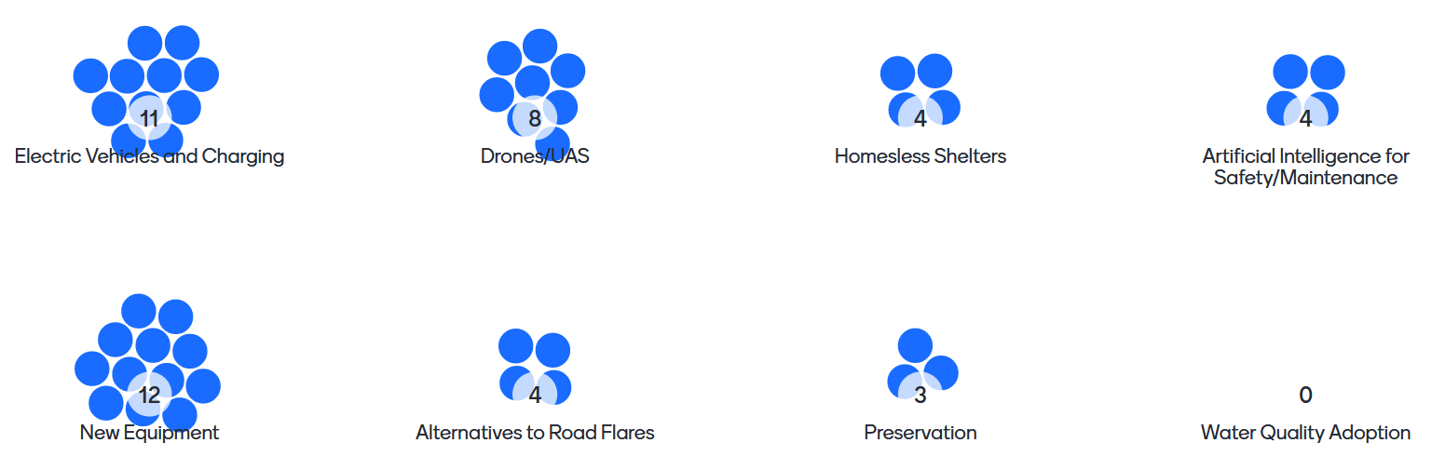

        - Top results, including the members who suggested them, follow:
          - Electric vehicles and charging - Tyler
          - New equipment - Sandi
          - Drones/UAS in maintenance - Todd
        - CTC will document the remaining topics so they can be addressed at a future time.
    - Member presentations – States give a quick update on their maintenance operations. Theresa (program update) and Ken (guardrail program) volunteered to give presentations.
    - The AASHTO Committee on Maintenance will hold its annual meeting in July. Brian will follow up with Heath and Sandi about sharing information from that meeting in Denver.
  - Attendees were asked to advise if they had tentative plans to attend the meeting in person. Responses follow: 12 were firm or very likely “Yes.”
    - CA: Theresa – Yes
    - CO (host): Tyler – Yes; David – Yes
    - CT: Bill – Yes, if allowed to travel
    - IN: Tony – Will be on vacation, but may send a sub
    - MD: Sandi – Yes
    - MI: Todd – No plans to travel yet
    - MN: Clark – Yes, or a representative
    - MO: Jimmy – Not traveling yet, he’s but hoping to travel by then
    - MS: Heath – Yes
    - ND: Jesse – Yes
    - NY: Ken – 80% Yes; planning to be there
    - OH: Doug – Yes
    - SC: Cruz – Yes
    - TX: Shelley – Yes, Alaina or Shelley will attend
    - FHWA: Antonio – Unknown travel status
    - TRB: James – CTC will check with him
Synthesis efforts
- Topics discussed in April minutes; are these or other topics of interest?
  - Brian – Synthesis to cast net wider beyond TAC to find out about topic. Search of literature and national survey.
  - For discussion in Denver.
Direction for No Boundaries — Discussion
- What should No Boundaries be doing more or less of? Build into Task Order #3.
  - For discussion in Denver.
Action items:
- Vaneza will work on implementing two working test versions of the No Boundaries database (Options #2 and #3); for presentation and discussion during the September meeting.
- CTC will work with Colorado DOT to put Task Order #2 in place for funding the September meeting.
- Kirsten will follow up with all states to firm up who is planning on attending the meeting; she will begin reaching out in July regarding flights
- Kirsten will reach out to downtown hotels on the same light rail line at CDOT headquarters.
- Brian will work with members to continue to develop the meeting agenda.
- Brian will work with members to develop the round-table discussion topics and questions.
Adjourn — Tyler Weldon

